ONLINE CHARITY MANAGEMENT SYSTEM

Himanshu Sikarwar1, Kapil Panwar2, kunal Srivastva3, Mradul Pratap4

*# Computer Science Department, ABES Engineering College 19th KM Stone, NH-09, Ghaziabad, Uttar Pradesh 201009*

[1Himanshu.20b0121088@abes.ac.in](mailto:1Himanshu.20b0121088@abes.ac.in) [2](mailto:2Harsh.20B0121190@abes.ac.in)[Kapil.20B0121171@abes.ac.in](mailto:Kapil.20B0121171@abes.ac.in) [3](mailto:3arif.20b0121176@abes.ac.in)[Kunal.20b0121129@abes.ac.in](mailto:Kunal.20b0121129@abes.ac.in) [4](mailto:4prakhar.20b0121146@abes.ac.in)[Mradul.20b0121102@abes.ac.in](mailto:Mradul.20b0121102@abes.ac.in)

Abstract- Charity is an act of kindness, where a person who has financially more than enough of what he or she needs contributes a part of his or her surplus income for the fulfilment of the needs of those who are less capable. The majority of NGOs has experienced difficulties in getting funds or other required things. Getting donor is a very hard task, and sometime dealing with some donor’s conditions can be a big challenge for NGOs to fulfil it.

This charity management system will help NGOs to find donors easily. This system has three modules namely, Admin, NGO and Donor. Admin can login using credentials and manage the request raised by NGO by approving or rejecting it. Approval will be done after verifying the NGO documents uploaded by NGO. Admin will get the report of NGOs who get donations. NGOs can register and raise request by uploading NGO documents.

Once admin gets the approval, they can login using credentials. NGO can raise request in need to the various registered donor. They can view the previous events list and donation report. Donor can simply register and login using credentials. They will get the notification of the request raised by NGOs for donation. They need to fill the details regarding donation on approval of request. Donor will get the date of donation. They can also view Donation history.

# Introduction

A charity management system is a software/website solution for a non-profit organization. It manages the charitable donations and also the donor base. Such a system includes features such as electronic fund transfer, donation management, fundraising, donor management, and event management.

There are certain key features that these systems offer to non-profits:

• Easily track donations and donors.

• Send gift messages to donors.

* Set up recurring payment plans.
* Get reports on their donations.
* Development of income resources (donation).
* Management and distribution of contributions to all the needy and low-income families.
* Optimum provision and utilization of operational, physical, and human resources.
* Organization and maintenance of facilities and family’s data to allow the ease of their access.
* Speeding up the practical procedures. Helping decision Makers in their strategic action plans.

# LITERATURE SURVEY

It appeared that important factors that make people to contribute to projects run by NGOs are small donations (many can afford it) and feeling of being a part (founder) of an important project. Joined contributions of a group focused on solving particular problem is a good example of utilizing so called social capital. It is also worth to notice that good atmosphere (fun, joy, concert) and even day of the week has an influence on number of participants and their will to contribute to projects presented during an event.

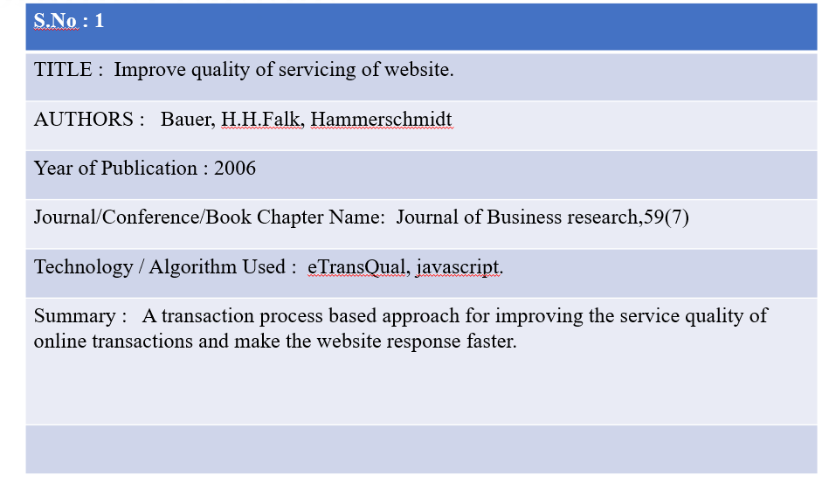

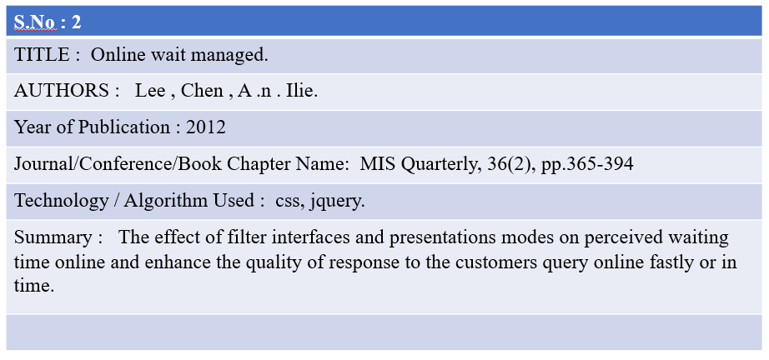

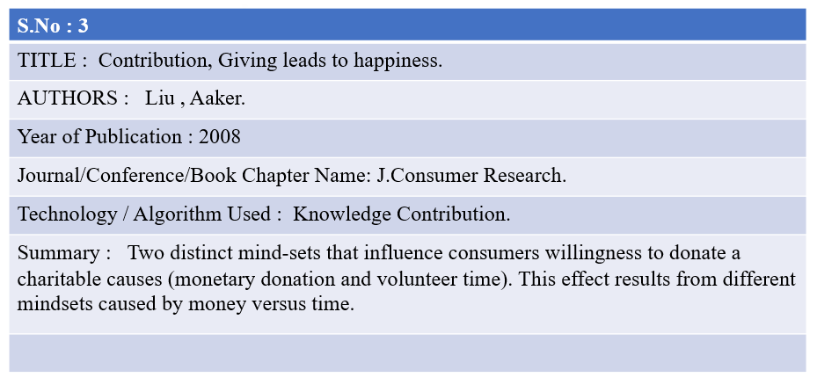

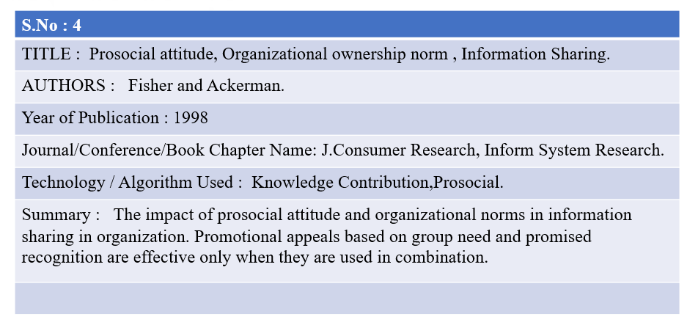

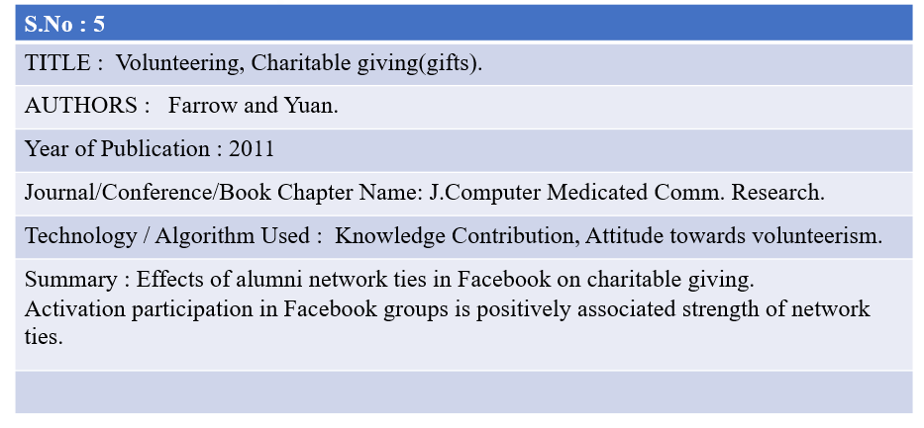

# CONCLUSION

Help directly. Donors shy away from spending on overhead and they may overestimate what portion of their donations goes toward fundraising and salaries (Bennett 2002). Charities can try to convince donors that their donations will help people directly by guaranteeing that their specific donations will not pay for overhead. They can also give donors the power to choose which cause their donation supports, which may increase donors’ confidence in the impact of their gift. Make a meaningful contribution to solving a problem. Donors tend to avoid contributing to needs that are large in scope, or that will last a long time. They like giving to charitable campaigns that are very close to succeeding already. But even if a charity is dealing with a difficult long-term issue that affects millions of people, they could still benefit by offering “small victories” to their donors. Charities should always give donors the option (but not the obligation) to publicize their giving, as well as the ability to share news of their gift on social media. Publicizing donations could also help charities convince future donors to give more. Feel good about giving. Donors told that giving will make them happier sometimes give more than those told about the benefits their gift will have on other people. Donors also claim to be willing to give more when they receive feedback from charities on the impact of their giving. Charities should ensure that donors understand what good their donations have enabled, and might also benefit by encouraging donors to feel good about their generous actions. Effective charities could take advantage of their detailed impact measurement by sending especially detailed thank-you notes. On the other hand, charities should be careful not to provide potential donors with external motivation to give; this could actually reduce contributions, by leading people to think of a charitable interaction as a transaction rather than a gift.

# REFERENCES

1.Harmon, R. (2003, March 13). System and method of funding a charity. Retrieved from

patents.google.com: <https://patents.google.com/patent/US20040181468A1/en>

2.Higgigs, L. (2006, July 12). Non profit and Voluntary Market sector. Retrieved from

onlinelibrary.wiley.com: <https://onlinelibrary.wiley.com/doi/abs/10.1002/nvsm.226>

3.Horn, J. (2002, february 13). Automated accounting fundraising system. Retrieved from

patents.google.com: <https://patents.google.com/patent/US20020116214A1/en>

4.Johnson, A. (2007, September 1). Fund-Raising effectiveness. Retrieved from

journals.sagepub.com: <https://journals.sagepub.com/doi/abs/10.1177/0275074006294390>

5.Kenya Charity Sweepstake. (2020). Retrieved from kenyacharity.com:

<http://kenyacharity.com/site/index/play/>

6.LANWORKS. (2016, August 15). Retrieved from lanworks.com: <https://lanworks.com.sg/>

+

7.Satzinger, J. W. (2008). Google Books. Retrieved from System Analysis and Design in a

Changing World: <https://books.google.co.ke/>